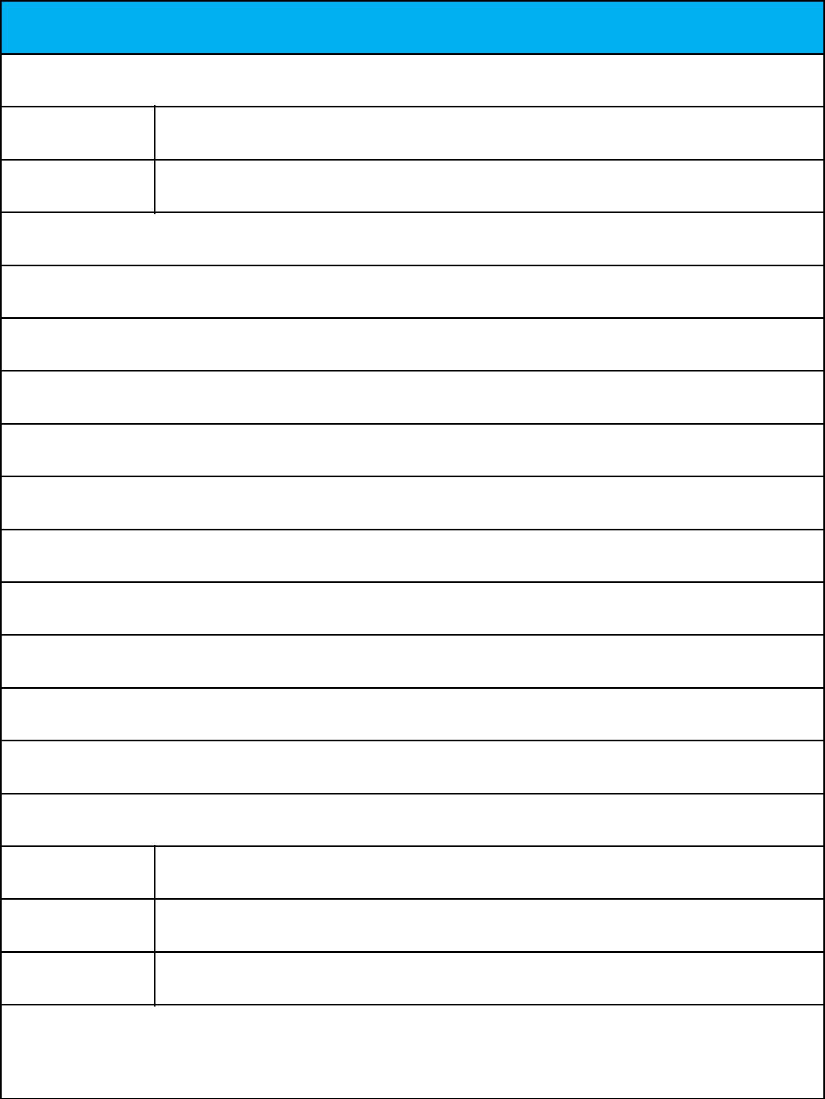
Rent Receipt Template

1. Employee details

Employee ID 1596730

Full Name Aasif Mashak Maniyar

2. Address of the rented house

B1-9002, Alcon Signare,Parge Nagar, Kondhwa Khurd, Pune- 411048

CITY: Kondhwa, Pune

STATE: Maharashtra PIN CODE: 411048

3. Rent details

Received with thanks from Aasif Mashak Maniyar

sum of Rs. Three Lakh Nineteen thousand rupees only

(Rupees 319000/- only)

towards the rent of the above-mentioned residential premises for the month of May 2023 to April 2024

Mode of Payment (Cash/Cheque/Online): Cash Payment Dated: 1st of each month

4. Landlord Details

PAN Number BOGPM9033Q

Full Name Attar Anjum Altaf

Landlord Signature

and Date

Note: The HRA tax benefit is applicable only for the amount paid towards rent. Payment towards other expenses like maintenance, water, electricity, food, security deposits, late payment charges etc. are excluded. If other expenses are being paid along with the rent, the rent receipt should contain a break-up of all the components paid.

